Bandit level 12 to level 13
To login to the level 12 use the username as
The following commands are used according to their usage it may show many errors if it does not get the ASCII file
 | cp ~/data.txt data.bin | Copy the original data.txt to a working file
 | xxd -r data.txt data.bin | Convert hexadecimal data into binary
 | file data.bin | Check the file type
 | mv data.bin data.gz | Rename it as a gzip file
 | gunzip -d data.gz | Decompress the gzip file
 | file data | Check the new file type
 | mv data data.bz2 | Rename it as a bzip2 file
 | bzip2 -d data.bz2 | Decompress the bzip2 file
 | mv data data.tar | Rename it as a TAR archive
 | tar -xf data.tar | Extract the TAR archive
 | file data6.bin | Check the extracted file type
 | bunzip2 data6.bin | Decompress the bzip2 file
 | file data6.bin.out | Check the resulting file type
 | tar -xf data6.bin.out | Extract the TAR archive
 | file data8.bin | Check the next file type
 | mv data8.bin data8.gz | Rename it as a gzip file
 | gunzip data8.gz | Decompress the gzip file
 | file data8 | Confirm it is ASCII text
 | cat data8 | Display the password

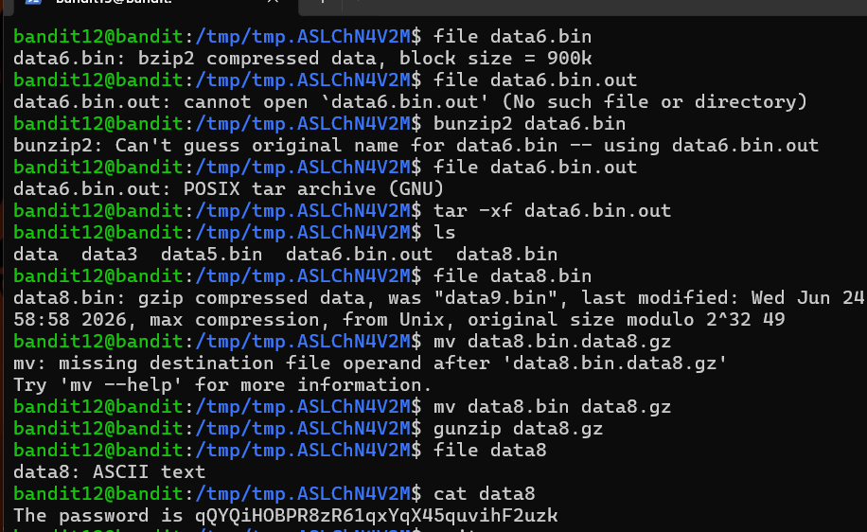
At finally we will get the password for the next level 13

